SQL CLASS - 4

TOPICS – TCL, DQL/DRL Commands

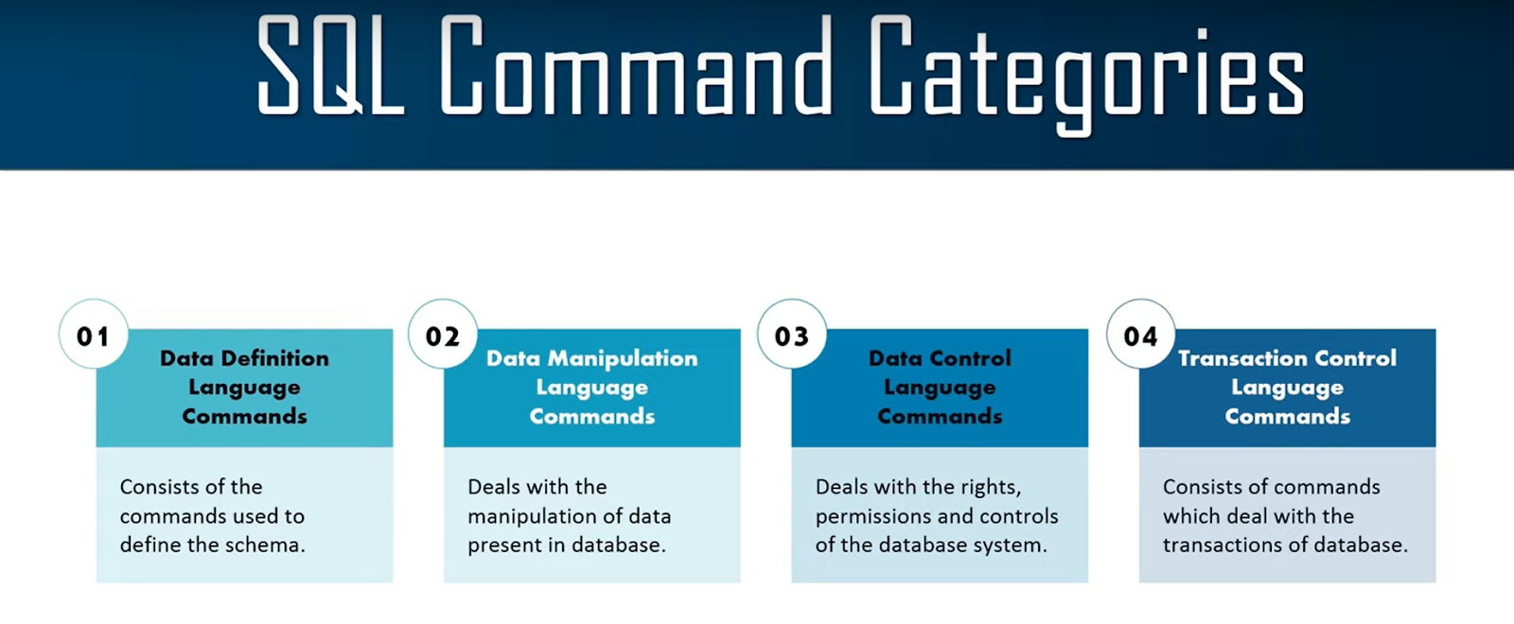

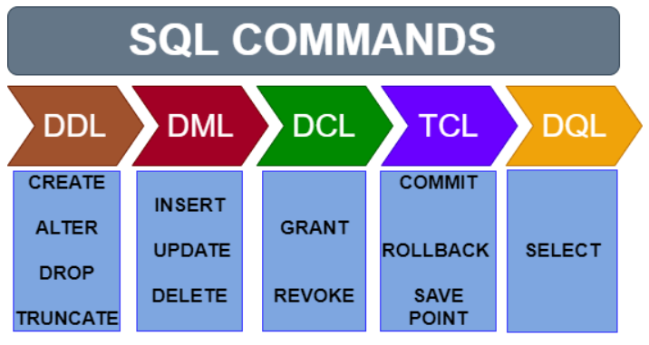

- Transactional Control Language (TCL) - Commit, Rollback, Savepoint

What is a Transaction?

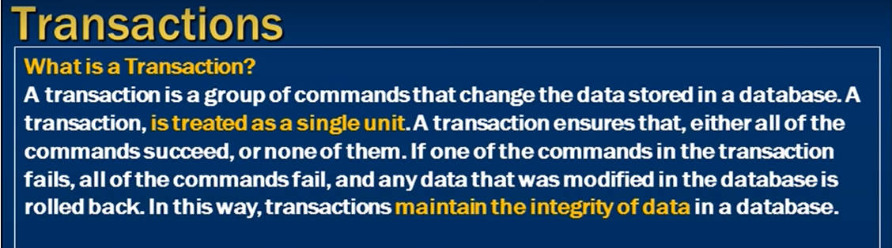

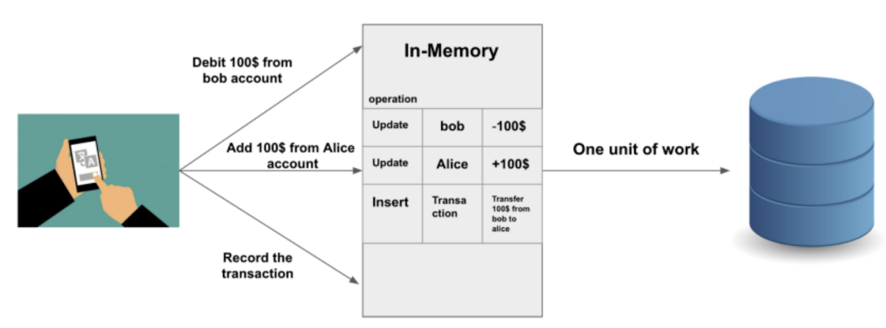

- Commit - To make changes permeant in database

- Commit is used to make changes permanent. When we use Commit in any query then the change made by that query will be permanent.
- We used to perform commit after DML operations
- We cannot Rollback after the Commit.

Syntax - Commit;
Example -

DELETE FROM studentsInfo WHERE StudentId = 2;
Commit;

- Rollback -

- Rollback is used to undo the changes made by any DML command but only before a commit is done.
- We can't Rollback data that has been committed in the database with the help of the commit keyword.

Syntax - Rollback;
Example -

DELETE FROM studentsInfo WHERE StudentId = 2;
Rollback;

- Savepoint -

- It is used to temporarily save a transaction so that you can rollback to that point whenever required.
- If there are 2 savepoints S1 and S2 and user rollback to savepoint S1 then S2 savepoint will be automatically deleted.

Syntax - ROLLBACK TO Savepoint_name;
Example -

DELETE FROM studentsInfo WHERE StudentId = 2;
DELETE FROM studentsInfo WHERE StudentId = 3;
SAVEPOINT S1;
DELETE FROM studentsInfo WHERE StudentId = 4;
SAVEPOINT S2;
DELETE FROM studentsInfo WHERE StudentId = 5;

ROLLBACK TO S2;
ROLLBACK TO S1;
(Note- After rollback to S1 you cannot use savepoint S2)

- Data Retrieval /Query Language (DRL/DQL) - Select

- Select - used to retrieve data from a table.

- It is used to Fetch or Retrieve or Display or Read data from the table.
- It is used to retrieve the information from the database objects for read only purpose.

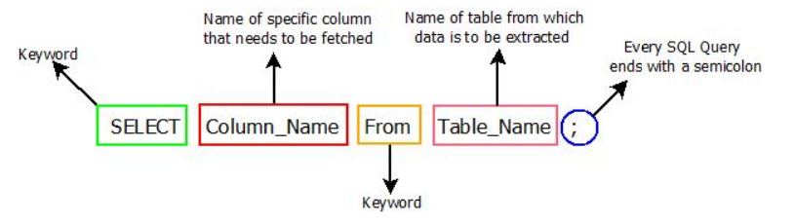

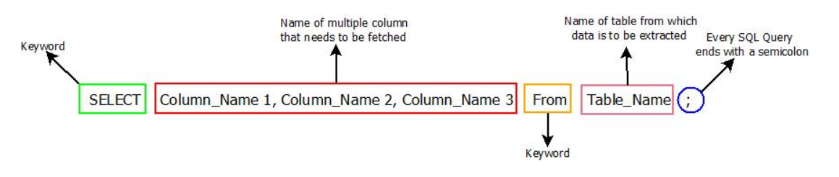

Syntax - SELECT * / list of columns FROM table_name WHERE condition;
Example -

SELECT * FROM studentsInfo;

SELECT StudentName, PhoneNumber, City FROM studentsInfo;

SELECT PhoneNumber, City, StudentName FROM studentsInfo;

SELECT * FROM studentsInfo WHERE StudentId = 1;

SELECT StudentName, PhoneNumber, city FROM studentsInfo WHERE StudentId = 1;

Perform arithmetic calculation or to print string using select -

Example -

SELECT 10 +12 FROM dual;
SELECT 10 +12/3 * 9 FROM dual;
SELECT (10 +17)/3 * 9;
SELECT ((100 + 100) - (50 + 50)) FROM dual;
SELECT 'Welcome to SQL Class' FROM dual;

__________________________THANK YOU____________________________

